|  |  |
| --- | --- |
| **Soal Praktikum**  *Practicum Case* |  |
| T0044 | COMP6175  Object Oriented Programming |
| **Teknik Informatika**  *Computer Science* | **E1-T0044-JL01** |
| **Periode Berlaku** Semester Genap 2015/2016  ***Valid on*** *Odd Semester Year 2015/2016* | **Revisi 00**  *Revision 00* |

## Learning Outcomes

* Differentiate the differences between conventional programming and OOP
* Describe the main features of OOP

## Topic

* Session 01 - Introduction

## Sub Topics

* My First Program in C++.
* Conversion of C to C++
* Stream Input
* Stream Output
* Data Type
* Arithmetic operator
* Logical Operator
* Selection

## Soal

*Case*

**Yummy Delivery Pizza** is one of the famous pizza shops that you can order many kinds of pizza. As a famous pizza shop, everyday they have so many transaction data that occur. To help them manage the company data, you are asked to create an application using C and C++ language. Here are the rules:

* There are 3 main menus :
  1. **Order Pizza**
  2. **Pay**
  3. **Exit**
* If user chooses “***Order Pizza***”, then the program will:
  + Display the name and price of the pizzas, such as:

1. Meat Lover Pizza (@ Rp. 80000,-)
2. Vegetarian Pizza (@ Rp. 50000,-)
   * Then, user is asked to choose which pizza user wants. Validate the **input** must be **between** **1** and **2**.
   * And then, the pizza will be added into the transaction.

* If user chooses “***Pay***”, then the program will:
  + If user has not order any pizza yet, then show display a message “**You are not buy anything..**”,and back to main menu.
  + If user has order a pizza(s), then **show** the ordered pizza(s) with **total price** and ask user to pay.
  + Validate the payment should be **greater** than or **equal** to total price.
  + Finally, show the change of the payment with these following formula:

|  |
| --- |
| **Change = payment – total price** |

* If user chooses “***Exit***”, then the program will end.

**For more details, please run the .EXE file.**

**Printscreen of main menu**

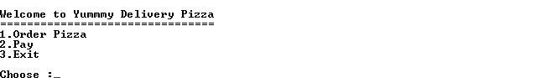

**Print screen of “Order Pizza”**

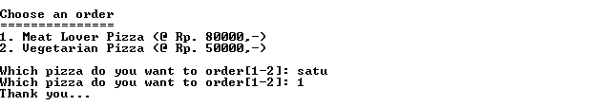

**Print screen of “Pay”**

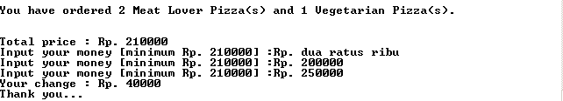

**Print screen of “Pay” (if user has not ordered any pizza yet)**



**If anyone does not understand, ask your assistant!**